
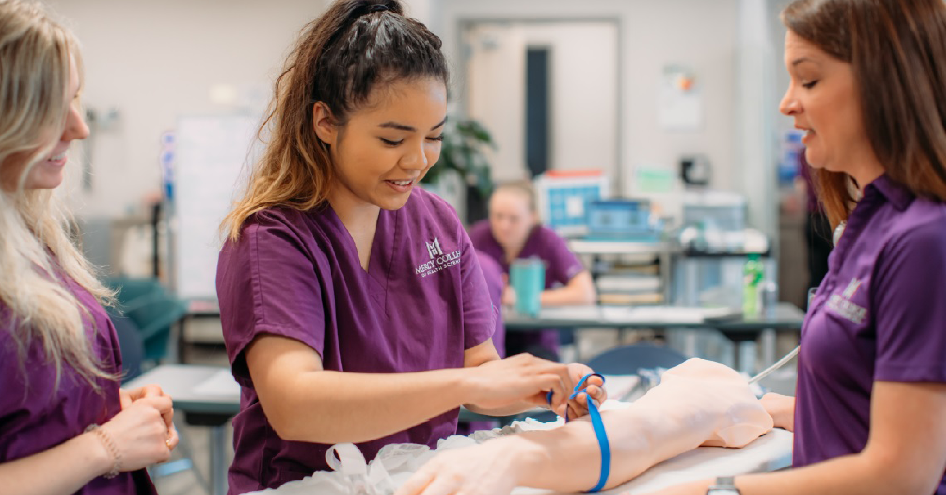

HEADER TITLE
[Sidebars are great for calling out important points from your text or adding additional info for quick reference, such as a schedule.
They are typically placed on the left, right, top or bottom of the page. But you can easily drag them to any position you prefer.
When you’re ready to add your content, just click here and start typing.]

Sidebar Title
Lorem ipsum dolor sit amet, consectetur adipiscing elit, sed do eiusmod tempor incididunt ut labore et dolore magna aliqua.
Ut enim ad minim veniam, quis nostrud exercitation ullamco laboris nisi ut aliquip ex ea commodo consequat.
Duis aute irure dolor in reprehenderit in voluptate velit esse cillum dolore eu fugiat nulla pariatur.
mchs.edu | 515-643-3180 | 928 6th Avenue Des Moines, IA 50309

