

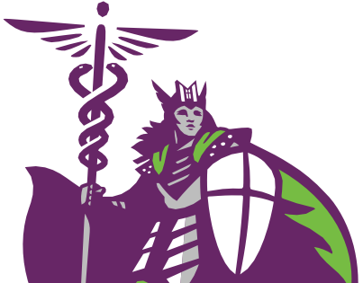

(515) 643-3180
MCHS.edu
928 6th Avenue | Des Moines, Iowa 50309

